## ****Soil NPK Sensor Features:****

This Soil NPK Sensor is provided with high-quality stainless steel probes which are completely rust-resistant, electrolytic resistant, salt, and alkali corrosion resistant. Therefore this Soil NPK Sensor is suitable for all kinds of soil. Another feature that I really like is its ability to detect alkaline soil, acid soil, substrate soil, seedling bed soil, and coconut bran soil. Moreover, this Soil NPK Sensor is IP68 grade waterproof and dustproof, to ensure the normal operation of components for a long time.

## ****Soil NPK Sensor Specifications:****

### ****NPK Sensor Pinout:****

[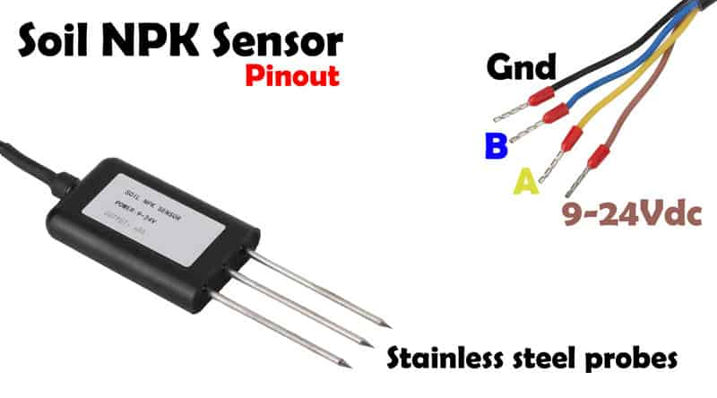](https://i1.wp.com/www.electroniclinic.com/wp-content/uploads/2021/03/soil-npk-sensor-pinout-scaled.jpg?ssl=1)

The Soil NPK Sensor has a total of 4 wires. The brown wire is the VCC wire and it should be connected with 9V-24Vdc Power Supply. The Black wire is the GND wire and it should be connected with the Arduino’s GND. The remaining two wires which are the Blue and Yellow wires these are the B and A wires and these two wires should be connected with the B and A pins of the Max485 Modbus module which I will explain in a minute.

So, You will need 9 to 24Vdc to power up this Soil NPK Sensor. The NPK Sensor supports 2400, 4800, and 9600 baud rates, due to which it can be used with different microcontroller boards like 8051 family of microcontrollers, PIC microcontrollers, Arduino boards, and so on. In this tutorial, I will use the Soil NPK Sensor with the Arduino board. The Soil NPK Sensor is provided with the Modbus communication port RS485 due to which it can be easily interfaced with the Arduino board using the Modbus module like MAX485/RS485 module. The working temperature is from 5 to 45 Celsius. The Nitrogen, phosphorus, and Potassium resolution is 1mg/kg or 1mg/liter. The measuring range of the Soil NPK Sensor is 0 to 1999mg/kg, and the working humidity is from 5 to 95%. The maximum power consumption is ≤ 0.15W.

### ****Voltage:****

9V-24V DC

Maximum Power Consumption: ≤ 0.15W

### ****Baud Rate:****

2400/4800/9600

### ****Working Temperature:****

5 to 45 ° C

### ****Resolution:****

1mg/kg (mg/l)

### ****Measuring Range:****

0-1999mg/kg

### ****Working Humidity:****

5 to 95% (relative humidity), no condensation

### ****Measurement Accuracy:****

±2%F.s

### ****Communication Port:****

RS485

### ****Protection Class:****

IP68